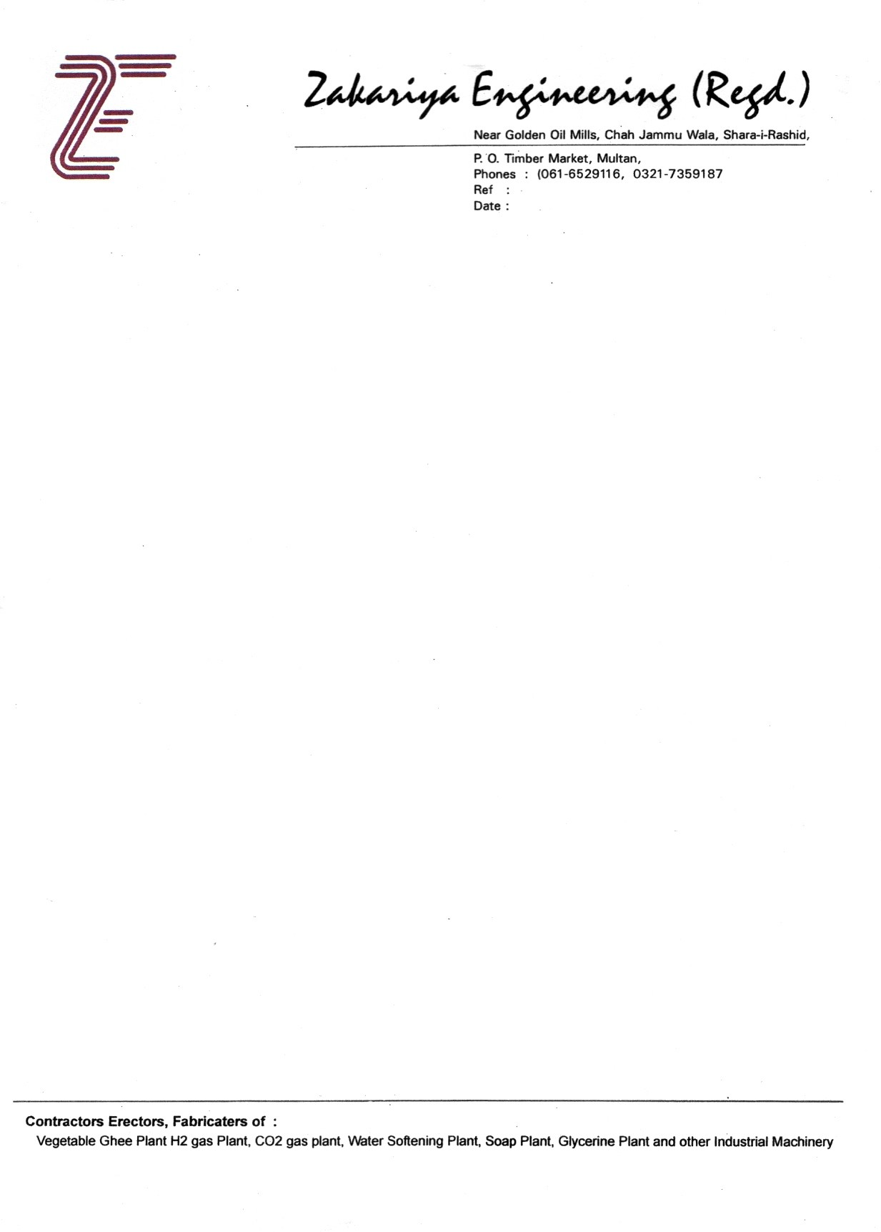

**TO WHOM IT MAY CONCERN**

Certified that MR. <Name> S/o <fname> has been worked with us as a <Designation> at Reliance Weaving Mills Unit No. 03 Multan from <From2> to <To2>.

During his stay with us we found him hard worked and skilled in his job. He is punctual and obedient.

We wish he become successful in his future life.

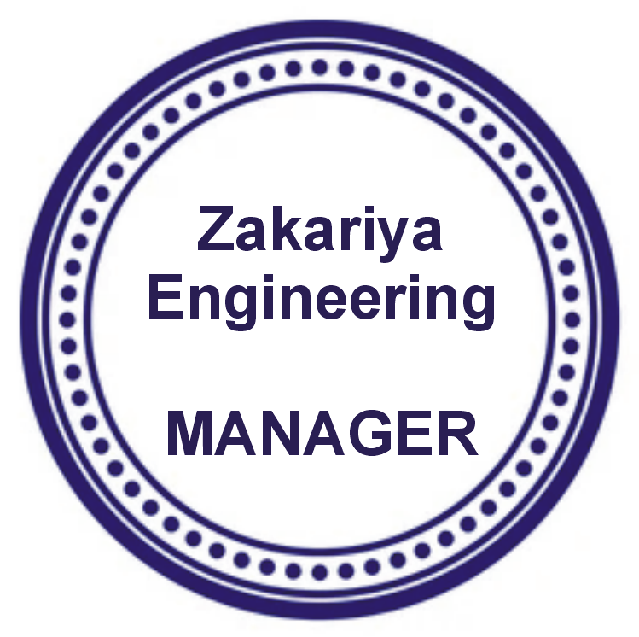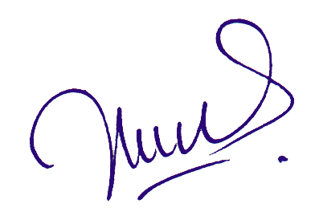

***Muhammad Babar Khan***

***(Manager) Zakariya Engineering (Regd.)***